The **sequence diagram** represents a seamless flow of actions among the key actors involved in the pharmaceutical sales forecasting process. It starts with the **Pharmacy Manager** requesting forecasts, followed by the **Data Engineer** providing historical data, and the **ML Engineer** ensuring proper training of the machine learning models. Finally, the **AI System** generates accurate forecasts using **XGBoost**, which the **Pharmacy Manager** uses to make informed decisions regarding inventory.

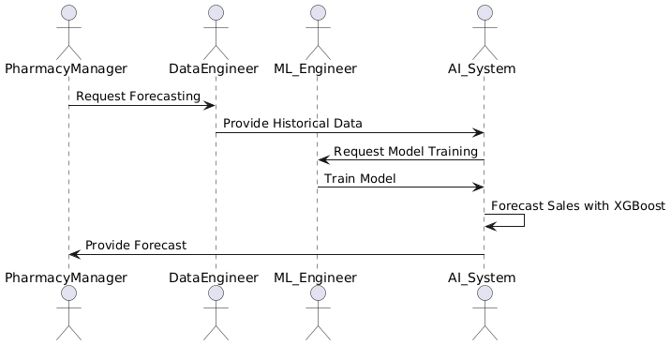

**Figure 1. Illustrates the step-by-step process of data flow and AI integration.**

1. **Pharmacy Manager**:
   * **Requests Forecasting**: Initiates the process by requesting a sales forecast.
   * **Receives Forecast**: Uses the forecast to manage inventory and stock.
2. **Data Engineer**:
   * **Provides Historical Data**: Supplies the historical sales data to the **AI System**.
3. **ML Engineer**:
   * **Requests Model Training**: Requests model training from the **AI System**.
   * **Trains Model**: Trains the forecasting model using historical data.
4. **AI System**:
   * **Forecasts Sales**: Generates sales forecasts using the **XGBoost model**.
   * **Provides Forecast**: Sends the forecast to the **Pharmacy Manager**.

**Workflow:**

1. **Pharmacy Manager** requests the forecast.
2. **Data Engineer** provides the historical data.
3. **ML Engineer** trains the model.
4. **AI System** generates and provides the sales forecast to the **Pharmacy Manager**.